Corey Wise – Team Leader

Discussed positions and formulated Gnatt chart.

Rosani elected to produce the Gnatt Chart

-------------------------

Took apart lathe and collect and organized objects.

Tool Slide – auto cad

-------------------------

Split in to, three groups of 3

Control: Corey , Miguel , Uc Tren

Electrical: Sunny, Sundeep, Nimesh

Mechanical: Rosani, Seam, Alexey

------------------------------

-Researched ball screws, the formula need and using this calculated the ball screws needed for our lathe

$$Lead=\frac{Chuck angular velocity \left(RPM\right)×Feed rate \left(\frac{mm}{rev}\right)}{Manual angular velocity \left(RPM\right)}$$

$$T_{ball screw}=\frac{F_{mot}×Lead}{2π×η_{ball screw}×1000}$$

With these two formulas and also the breakdown of our forces and determining the cutting forces (produced by Miguel) we were able to obtain the toque on the ball screws

For the z-axis or The Apron we got a total force of **4632.5N**

$$F_{mot}=F_{F}+F_{A}=1182.5N+3450 N=4632.5N$$

Then using the above ball screw formula we get **8.2Nm**

And apply the safety factor we obtain the final **10.9Nm**

**Repeating this method for the x-axis or tool post**

We get $2868.2N$ for total collective force which makes our ball screw torques **5.1Nm** which makes it **6.8Nm**  with a safety factor.

--------------------------------------------

Bill of materials for our contract

I was tasked with creating a rough bill of materials which include part from all three groups and the approximate pricing already placed into the contract and github

----------------------------------------

3D auto cad of the gauge slide that sit atop the saddle (rough)

Still need some minor detail the be completed and polished for the future assembly’s

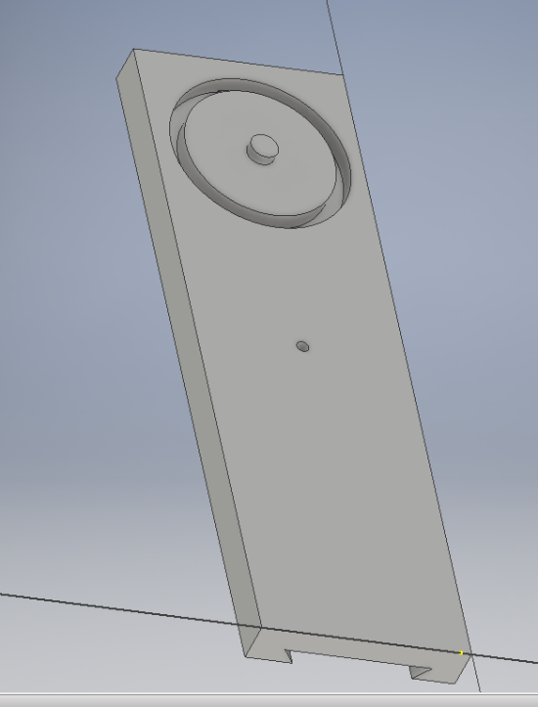

PROGRESS REPORT 2 – Week 20

Unfortunately I was away for many classes so I can’t say that I have done much this term to further the project.

I have lent help with various parts of the project like help assembling the lathe

Organising the group to better plan the group Progress Report

Helping tearing apart the lathe to clean it up and prepare to update lathe parts